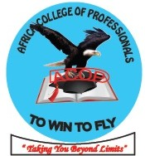AFRICA COLLEGE OF PROFESSIONALS (ACOP)

KAWEMPE PLAZA P.O.BOX 10917 KAMPALA-UGANDA EAST AFRICA

Website: www.afcop.net [Email: info@afcop.net/amps@gmail.com](mailto:Email:%20info@afcop.net/amps@gmail.com)

TEL: +256789967172/703847861

**ACOP** is an autonomous college which started with the vital role of enhancing academic and developing career from different fields while emphasizing professionalism, covering a wider scope of working class caliber and students from tertiary institutions. we therefore base ourselves on a distance learning system in order to save time for professional workers to concentrate on their work schedules as they are also studying with us.

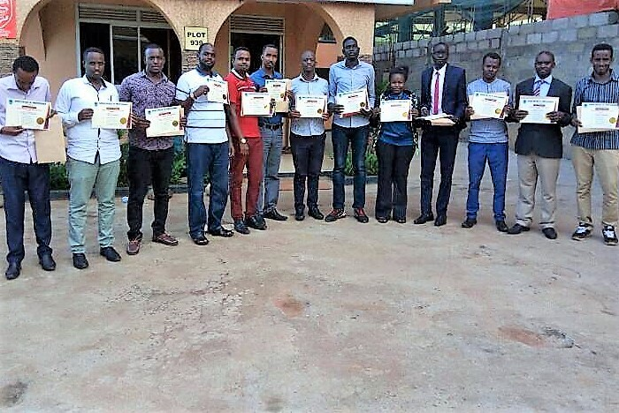

**ACOP** currently operates in 11 African counties, including Uganda, Kenya, Rwanda, Tanzania, Nigeria, Democratic Republic of Congo, Southern Sudan, Zimbabwe, Malawi, Ethiopia and Burundi

we reach our students through online teaching, an outreach lecturing with quality world class information which cannot leave you academically the same again.

**ACOP Mission**

To establish a strong academically rooted and vibrant world class professional college, through employing specialized personnel and tools used in academic learning.

**ACOP vision**

To enhance and develop workforce among the professionals in sustaining optimum productivity and service delivery.

**ACOP CORE VALUES**

* Professionalism and
* Integrity

**AFRICA COLLEGE OF PROFESSIONALS (ACOP) INTRODUCES E-LEARNING SYSTEM**

Africa college of professionals’ E-Leaning system is being worked on. After getting so many requesting messages from our potential participants and students allover Africa and other continents, ACOP, has finally made a decision to start an E-Learning program to extend the professional ethics all over the world, and its effectively beginning on February 2018 intake.

This system will allow those who would love to upgrade in their academics through online. Everything will be done online that is applying, admitting, reading material delivery, lectures, exams and results will all be done and uploaded online with the main aim of serving the entire world.

We shall be offering different programs from certificate level up to masters.

*“taking you beyond limits”*

**NOTICE**

This is to inform all our potential participants from *Uganda (Kampala, Mbale, Gulu and Alua**), South Sudan (Juba), South Sudan in (Mogadishu), Tanzania (Dare salaam), Kenya (Nairobi and Mombasa),*

*Ethiopia in (Ads Ababa), Burundi in (Bujumbura), Nigeria, in (Abuja and Lagos), South Africa in (Pretoria) DRC (Kinshasa) and Egypt in (Cairo)*. Who are ready for our distance Learning monthly certificate programs, September intake is now going on you can apply by online receive the reading materials or you can call the academic registrar on **+256 703 847 861** for more guidelines.

*“taking you beyond limits”*

**WHAT IS ABOUT AFRICA COLLEGE OF PROFESSIONALS (ACOP) MONTHLY COURSE?**

ACOP’s monthly course simply is a short course applied by anyone who has completed his or her Advanced Certificate of Education or equivalent, and is willing to enhance his academics or career.

This short certificate lasts for only one month, but with a full satisfied module content in relation to your career, with the aim of winning promotions at your work place or equipping and consolidating your CV for higher chances of getting anew and good paying Jos.

ACOP’s monthly courses are based on distance learning, and ACOP’s professional Lecturers interact with participants twice in a month followed by assessment tests and certificates of completion.

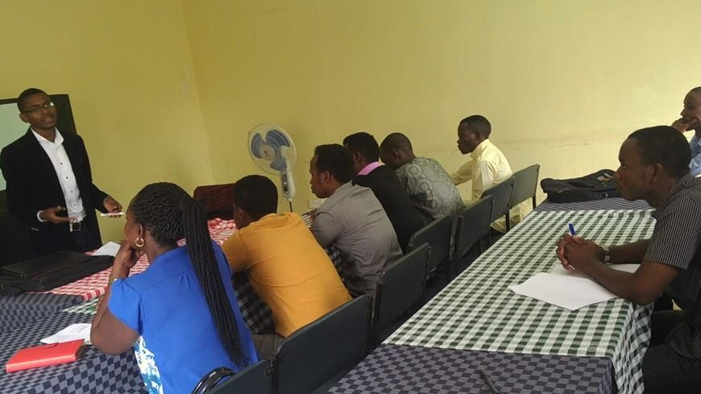

ACOP’s monthly courses are now widely demanded by Uganda, South Sudan, Somalia, Ethiopia, Burundi, Nigeria, EGYPT, Ghana, south Africa, Kenya, DRC and Zimbabwe. And most of participants from such countries have been positively testifying about the value of these courses, many have been promoted at work, and others got better paying jobs after having ACOP certificate attached to their academic documents.

***Is it expensive to enroll on ACOP’s monthly course?***

It’s actually not so expensive to enroll on Africa college of professionals’ monthly course, it’s as low as **$80** **(eighty US dollars**) only.

***How to enroll on ACOP’s monthly course?***

And then you choose which certificate you want to enroll on, you will be requested to download the application form, fill it and then reupload, from there you will receive notifications on how to go on with learning from ACOP administrators until you complete your course and get your certificate.

***Is ACOP’s monthly course limited to Africa?***

Obviously not, that’s why we have introduced E-learning system where everyone worldwide is also given this great chance to study with Africa College of Professionals, and gain that tremendous professional and cooperate way of thinking. So, we are registering participants from United Arabic Emirates (UAE) and other continents.

*“taking you beyond limits”*

**ACOP’S MONTHLY/LANGUAGE COURSE APPLICATION FORM.**

This is downloadable Africa College of Professionals (ACOP) Monthly Application Form, which should be filled by potential participants with a vision of enhancing their career and academics.

So, download, fill, reupload and send it to the given official ACOP Email addresses given at the extreme end of the page below, and wait for a notification message within 24 hours from ACOP administrators for further guidelines. Date……………………………………………………………

|  |
| --- |
| Name: |

**Use capital letters and fill the table below**

|  |  |
| --- | --- |
| Date of birth(DOB); | Gender; |
| Course Applied for Is; | For which Month; |
| Country Origin; | District/State; |
| Physical Address; | TEL; |
| Email Address; | P.O. Box No; |
| Father’s Name; | TEL; |
| Next of Kin; | TEL; |
| Mother’s Name; | TEL; |
| Sponsor’s Name; | TEL; |
| The Level of Education | The Former Institute/College |

Please note that;

Cases of impersonation, falsification of information/document fraudulent access, whenever discovered either at registration or afterwards will lead to automatic cancellation of admission.

Every participant is obliged to pay all the fees, before he/she can be allowed to the reading materials as well as exams.

Attach your academic documents ***(at least Advanced Certificate of Education or equivalent)*** to this application form and bring them to any of our resource points nearby, or scan the documents and upload them and send them to

***Our official email address;*** [info@afcop.net/admin@afcop.net](mailto:info@afcop.net/admin@afcop.net)

***Thank you for choosing Africa College of Professionals, A home of Professionals***

*“taking you beyond limits”*

**ACOP OPENS A NEW RESOURCE POINT IN KAMPALA - UGANDA**

ACOP opens a new resource point in Kampala Uganda, the launching occasion was held at Emiland Hotel in Kampala, where ACOP coordinators in Uganda attended and honored the occasion. It was a was so grateful with an immense happiness especially from some participants who have been travelling long distances from Kampala to Kisoro district for ACOP learning assistance.

Speaking at Emirand Hotel, ACOP Nigerian ambassador Dr.Adamu Emmanuel and still the acting Chairman of Council Committee, expressed his un resistible gratitude to ACOP Management Committee in Uganda for a such great goal achieved.

The ACOP Ambassador in Nigeria, encouraged ACOP participants and students in Uganda to effectively use the resource point effectively to achieve their professional needs and to keep holding ACOP flag higher without forgetting its core values.

**ACOP LAUNCHES ANOTHER HANDBOOK**

Many students and professional participants have been requesting ACOP research professionals to write a book about research, finally prayers for many have been answered.

Research professionals from Africa College of Professionals, pulled up their resource mind together and wrote a research book titled **“*BASICS IN RESEARCH MANAGEMENT”****.* it’s good, and summarized research guiding book, which will assist and enhance knowledge to the researchers.

It was then launched by Prof. W. Ekere, the head of research department in Africa College of Professionals. So, the book will be available on Amazon selling site at cost of ***US $10 Dollars*** only, and starting from 5th January 2018, it will be available, for those who need hard copies can contact ACOP official emails, place an order now and receive them, as many as you want.

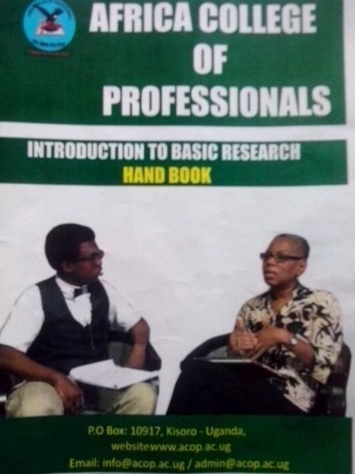 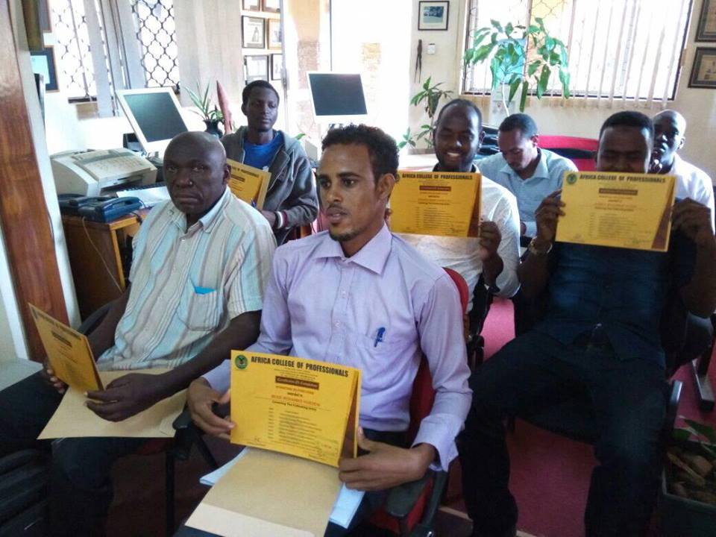

**AFRICA COLLEGE OF PROFESSIONALS INTRODUCES LANGUAGE LESSONS**

**English**

**French**

**Swahili**

**Register now for language lessons.**

**Campuses’ Coaching Initiative Programme.**

**Mathematics**

**Statistics**

**Economic**

**Accounting**

**CONTACT US** Find us at Chambers House KISORO Western Uganda, or our regional office at Kawempe Plaza in Kampala Uganda.

or visit us on our official **Facebook page Africa college of professionals**

website page www.afcop.net **or call us on**

**+256 789 967 172 or +256 703 847 861**